**EXPERIMENT 4**

**VERIFICATION AND INTERPRETATION OF TRUTH TABLES FOR NAND, NOR, EXCLUSIVE OR (EX-OR), EXCLUSIVE NOR (EX-NOR) GATES.**

**Required IC’s:**

7408 AND Gate

7432 OR Gate

7400 NAND Gate

7404 INV Gate

7402 NOR Gate

7486 XOR Gate

74266 XNOR Gate

**Theory:**

**NAND Gate**

NAND gate is actually a series of AND gate with NOT gate. If we connect the output of an AND gate to the input of a NOT gate, this combination will work as NOT-AND or NAND gate. Its output is 1 when any or all inputs are 0, otherwise output is 1.

**AND followed by INVERT**

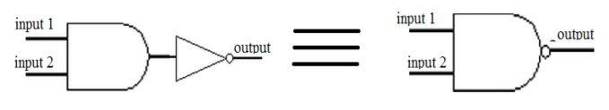

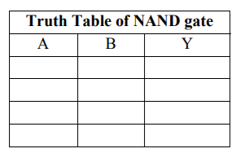

**NOR Gate**

NOR gate is actually a series of OR gate with NOT gate. If we connect the output of an OR gate to the input of a NOT gate, this combination will work as NOT-OR or NOR gate. Its output is 0 when any or all inputs are 1, otherwise output is 1.

**OR followed by INVERT**

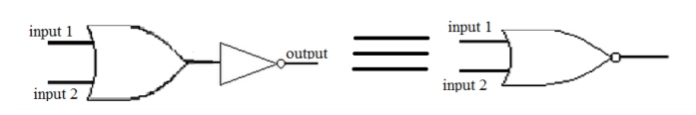

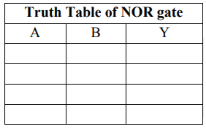

**Exclusive OR (X-OR) Gate**

X-OR gate produces an output as 1, when number of 1’s at its inputs is **odd**, otherwise output is 0. It has two inputs and one output.

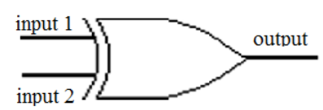

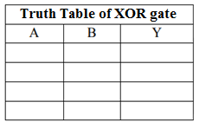

**Exclusive NOR (X-NOR) Gate**

X-NOR gate produces an output as 1, when number of 1’s at its inputs is **not odd**, otherwise output is 0. It has two inputs and one output.

**XNOR: XNOR equal to XOR followed by NOT; (A XNOR B) = not (A XOR B).**

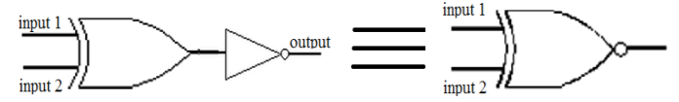

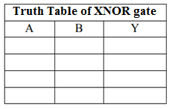

**CONCLUSION**

**LAB TASK**

1. **How to implement NOT, AND, and OR gate using NAND gates only.**

1. **How to implement NOT, AND, and OR gate using NOR gates only.**